Copyright and license agreement

In submitting a short research article (proceeding, abstract ) _Experimental studies of phase formation in the olivine – magnesite – sulfur and olivine – magnesite – pyrite systems at high P, T – parameters_______________________________________________________________
to V.I. Vernadsky Institute of Geochemistry and Analytical Chemistry for proceeding book of the XXXIV International Conference on "Magmatism of the Earth and related strategic metal deposits"
I certify that:
1. I am authorized by my co-authors to enter into these arrangements.
2. I warrant, on behalf of myself and my co-authors, that:
- the abstract is original, has not been formally published as an article in any peer-reviewed journal, is not under consideration by any other journal and does not infringe any existing copyright or any other third party rights;
- I am/we are the sole author(s) of the article and have full authority to enter into this agreement and in granting rights to V.I. Vernadsky Institute of Geochemistry and Analytical Chemistry are not in breach of any other obligation. If the law requires that the article be published in the public domain, I/we will notify V.I. Vernadsky Institute of Geochemistry and Analytical Chemistry at the time of submission upon which clauses 3 through 4 inclusive do not apply;
- the article contains nothing that is unlawful, libellous, or which would, if published, constitute a breach of contract or of confidence or of commitment given to secrecy;
- I/we have taken due care to ensure the integrity of the article. To my/our - and currently accepted scientific - knowledge all statements contained in it purporting to be facts are true and any formula or instruction contained in the article will not, if followed accurately, cause any injury, illness or damage to the user.
And I agree to the agreement, under which all abstracts of will be licensed:

Anyone is free to:
Share—copy and redistribute the material in any medium or format
Adapt—remix, transform, and build upon the material
for any purpose, even commercially.
The licensor cannot revoke these freedoms as long as you follow the license terms.
No additional restrictions—You may not apply legal terms or technological measures that legally restrict others from doing anything the license permits.
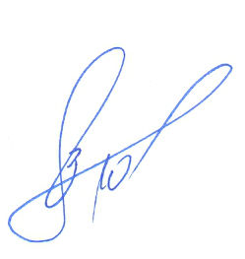
Statutory fair use and other rights are in no way affected by the above.

Author(s): Zdrokov E.V.
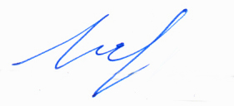
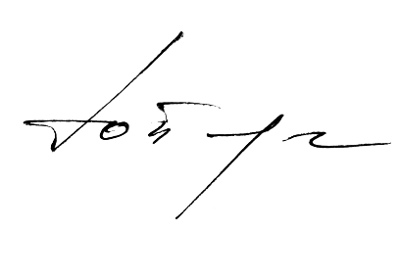
Bataleva Y.V.
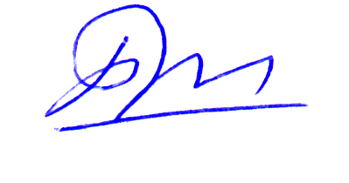
Palyanov Y.N.
Borzdov Y.M.

