EVIDENCE FOR MANTLE HYDRATION BY PHLOGOPITE METASOMATISM BENEATH ARKHANGELSK DIAMONDIFEROUS PROVINCE

Kolesnichenko M.V.^{1,2}, Zedgenizov D.A.^{1,2}, Shchukina E.V.^{1,2}, Litasov K.D.^{1,2}
¹ V.S. Sobolev Institute of Geology and Mineralogy SB RAS, Novosibirsk, Russia, m.kolesnichenko@igm.nsc.ru
² Novosibirsk State University, Novosibirsk, Russia

Olivine is major mineral of peridotites and may be an important host of hydrogen in the Earth’s upper mantle, and the OH abundance in this mineral defines many important physical properties of the planet’s interior [Bell et al., 2003]. It is widely known that mantle olivine samples could contain different amounts of water from minimal to the maximal water storage capacity [Schmädicke et al., 2013]. Peridotite xenoliths from V. Grib kimberlite pipe (Arkhangelsk diamondiferous province, Russia) have been studied in order to identify metasomatic alteration and water enrichment.
The incorporation of hydrogen in olivine of mantle xenoliths from V. Grib kimberlite pipe was investigated by infrared spectroscopy. IR spectra were collected in the OH stretching region on oriented single crystals using a conventional IR source at ambient conditions. The preparation of samples for IR included several stages. First, we selected most transparent fragments of minerals with no optically or macroscopically visible inclusions or cracks. Then, we determined the orientation of minerals by observing interference figures using a petrographic microscope. Finally, each fragment was fixed on a glass slide with Crystalbond thermoplastics and then double-side polished using abrasive clothes. Olivine grains were analyzed twice in two perpendicular orientations with the polarizer parallel to the optical indicatrix. Absorption bands due to O-H vibrations in olivines of V. Grib peridotite xenoliths are located between 3700 and 3100 cm⁻¹.
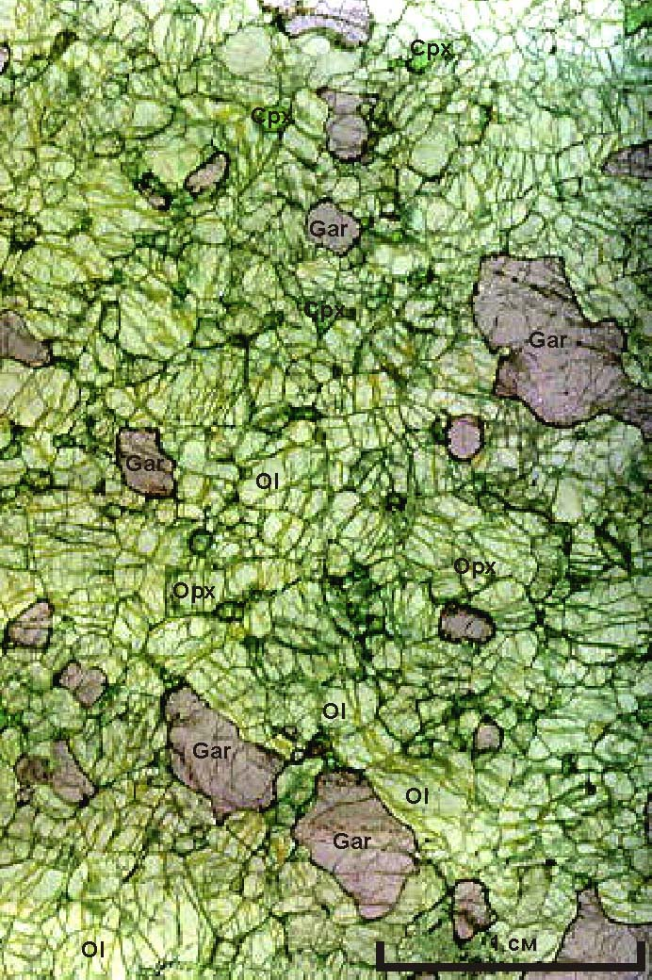  a | 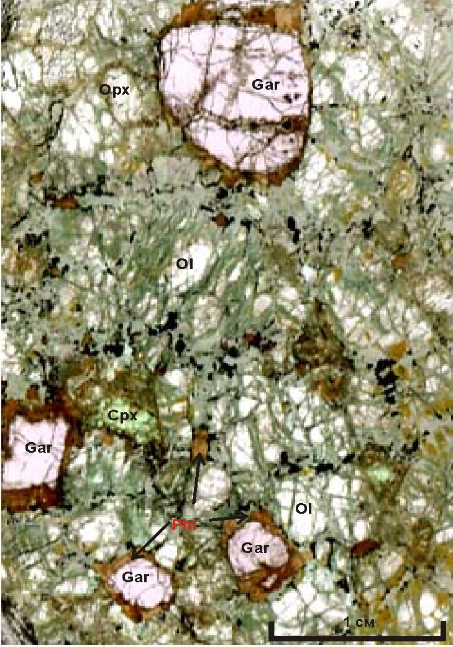  b
Fig. 1. Photographs of peridotites. a, garnet lherzolite; b, phlogopite-garnet lherzolite

The samples are divided into two groups: garnet lherzolites and phlogopite-garnet lherzolites (Fig.1). The peridotites of both groups are of two structural varieties: protogranular and transitional from protogranular to porphyroclastic. Olivines from garnet lherzolites are characterized by higher Mg# 92.2-92.6 compared with olivines from phlogopite-bearing xenoliths (Mg# 90.9-91.5). Water content in olivines decreases with increasing magnesium number Mg#. The calculated equilibration temperatures [Brey & Koehler, 1990] for studied lherzolites vary from 790 to 1020 °C (Fig.2). This correlation were not previously observed in olivines from peridotites of Udachnaya kimberlites (Yakutia, Russia), where high- and low-temperature trends differ by water content [Kolesnichenko et al., 2017]. The higher water content is found in olivines from low-temperature phlogopite-garnet lherzolites from V.Grib pipe, 39-84 ppm. Higher amounts of water in phlogopite-garnet lherzolite may indicate an enrichment caused by phlogopite metasomatism.
This work was partially supported by the Ministry of Education and Science of the Russian Federation (project no. 14.B37.21.0457 and project no. 14.Y26.31.0018), RFBR project No 16-35-00317.
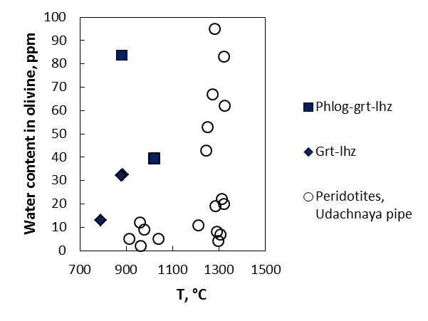

Fig. 2. Olivine water content vs. temperature calculated using [Brey & Koehler, 1990]

References:
Bell, D.R., Rossman, G.R., Maldener, J., Endisch, D., Rauch, F. (2003). A quantitative determination of the absolute amount and calibration of the IR spectrum. J. Geophys. Res., 108: B2, 2105

Brey, G.P., Koehler, T. (1990) Geothermobarometry in four-phase lherzolites II. New thermobarometers, and practical assessment of existing thermobarometers. J. Petrol., 31, 1353-1378.

Kolesnichenko M.V., Zedgenizov D.A., Litasov K.D., Safonova I.Yu., Ragozin A.L. (2017) Heterogeneous distribution of water in the mantle beneath the central Siberian Craton: Implications from the Udachnaya Kimberlite Pipe. Gondwana Res. http://dx.doi.org/10.1016/j.gr.2016.09.011.

Schmädicke, E., Jürgen, G., Witt-Eickschen, G., Brätz, H. (2013). Hydroxyl incorporation and mineral composition. Am. Min., 98: 1870-1880.

