УДК 550.93 + 552.93 (470.21)

SOURCES OF MATTER FOR RARE METAL PEGMATITES OF THE GREENSTONE BELT KOLMOZERO-VORONYA (KOLA REGION): ISOTOPE-GEOCHRONOLOGICAL STUDY OF TOURMALINE-MUSCOVITE GRANITES
Kudryashov N.M.¹, Udoratina O.V.², Coble M.A.³, Steshenko E.N.¹
¹Geological Institute of Kola SC RAS, Apatity, Russia, nik@geoksc.apatity.ru
²Institute of Geology of Komi SC UB RAS, Syktyvkar, udoratina@geo.komisc.ru
³Stanford University, USA, coblem@stanford.edu

An important task of study of rare metal pegmatites is the establishment of their genetic relations with granites, if any, and the determination of the time of occurrence of the ore mineralization. To address these questions, we connected zircon U-Pb geochronology aimed at determining the time of formation of both the granites ancestral for the pegmatites and the pegmatites themselves.
The Kolmozero-Voronya greenstone belt is confined to the central part of the suture zone separating the Murmansk domain from the Central Kola and Keivsky domains. The belt is represented by Late Archaean sedimentary-volcanogenic rocks (2.9-2.5 Ga). Within its limits the deposits of rare metal pegmatites (Li, Cs with associated Nb, Ta, Be) are concentrated. The pegmatite fields are located among amphibolites and gabbroic intrusions in the north-western and south-eastern parts of the belt. The age of the pegmatites within the belt, according to the available U-Pb datings for monazite and Rb-Sr isochronous method for bulk samples, was estimated at 2.7-2.6 Ga . Until now there is no generally accepted view on the genetic affiliation of the pegmatites. Various authors suggest association of the pegmatites with all types of granitoids within the region: plagiogranites, tonalites, amphibole-biotite granodiorites, microcline granites, alkaline granites, and also muscovite-tourmaline granites. The connection of the rare metal pegmatites with the processes of granitization has been also suggested to be associated with the formation of microcline granites (palingenic metasomatic granites).
Prior to this study, isotope dating has been obtained for a number of rock complexes, which may be possible candidates for the role of source granites for the rare metal pegmatites. These rocks belong to the differentiated sanukitoid Porosozersky massif represented by a series of gabbrodiorite - quartz monzodiorite - granodiorite - microcline-plagioclase granite. U-Pb (ID TIMS) age of the zircon from the rocks of the series is within the range of 2.73-2.68 Ga (Kudryashov et al., 2013). The age of the plagiogranites and tonalites from the Murmansk block, framing the rocks of the Kolmozero-Voronya greenstone belt, is defined as Late Archaean 2.8-2.7 Ga. The massifs of alkaline granites, located within the Keyvsky block, have the age of 2.65-2.67 Ga (Zozulya et al., 2005). Zircon in the pegmatites is overwhelming represented by broken crystals fragments due to fluid processes, and cannot be reliably used as a geochronometer to determine the crystallization age of the pegmatites. The use of non-traditional minerals-geochronometers with specially developed methods of separation of uranium and lead, allow estimating the time of formation and/or alteration of the pegmatites. The isotope-geochronological studies of tourmaline (shorl) from muscovite-tourmaline are Pb-Pb isochronous age of 2520±70 Ma. From the sample of the pegmatites taken from the Vasin-Mylk pits, tantalite and microlite were isolated for U-Pb isotope-geochronological study. The grains of tantalite and microlite are characterized by intraphase heterogeneity reflecting postcrystallization processes of changes of the mineral, probably metamictization. For the tantalite, a discordant age 2503±36 Ma was obtained, and for the microlite, a discordant age was 2454±8 Ma (Kudryashov et al., 2015). The obtained values ​​ages of the tantalite and microlite possibly fix the time of crystallization of these minerals during the formation of rare metal pegmatites at the Archaean-Proterozoic boundary.
To determine the U-Pb crystallization age of zircon from the tourmaline-muscovite granites, a local isotope-geochronological study of the zircon grains was performed at the Stanford University and U.S. Geological Survey SHRIMP-RG microprobe. The isolated zircon from the tourmaline-muscovite granite sample (KV-76) is represented by slightly modified brownish crystals of zircon type with the size 100-150 μm. The internal structure is characterized by the intraphase heterogeneity expressed both as the alternation of dark and light zones in the marginal parts of grains, and as diffused dark spots in the center of the grains. The contours of the zones are blurred, rectilinear and, apparently, reflect the growth of the crystals from the melt. The Pb-U isotope results of the analyzed zircon grains are shown in Fig. 1
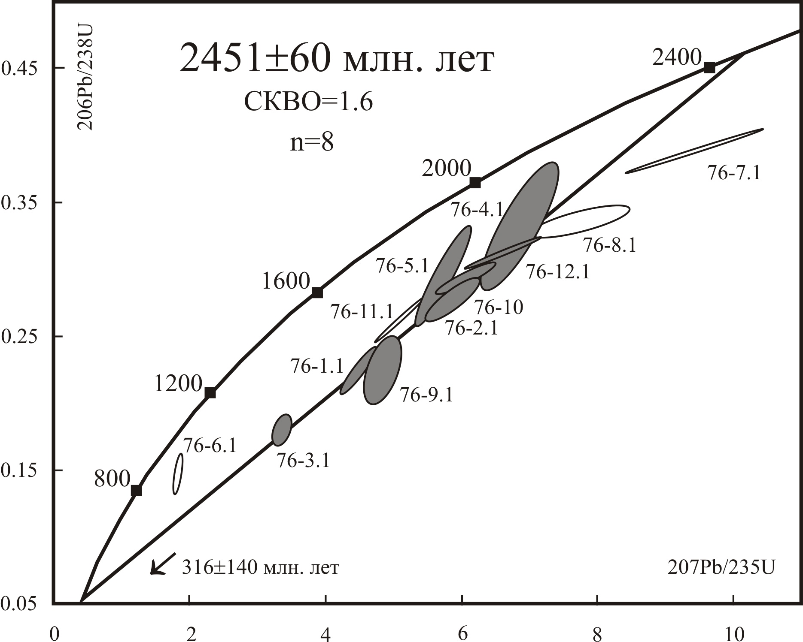

Fig. 1. Diagram with concordia for the tourmaline-muscovite granites. Gray ellipses - analytical data included in the calculation of the discordia; transparent ellipses - not included in the calculation.

The discordant age, calculated for 8 analyzed points of zircon, was 2451±61 Ma, MSWD=1.6. As can be seen in Fig. 1, the analytical points are strongly discordant, which indicates the original U-Pb system is not in equilibrium. The zircon is highly enriched in uranium - 2500-3000 ppm and has low U/Th=0.01-0.04, which possibly indicates the metasomatic processes. Thus, the upper intersection of the discordia with an intercept age of ~2.45 Ga likely reflects the crystallization time of zircon during the formation of the tourmaline-muscovite granites, and the high discordance is associated with a subsequent change in the zircon.
Zircon from the sample (KV-45) was extracted from the central part of the intrusion of tourmaline-muscovite granites of lake area Litsa (Gordienko, 1970). Grains are represented by slightly modified brown crystals of zircon type with the size of 100-200 μm. The internal structure is characterized by intra-phase heterogeneity. The central parts of the grains are light and translucent, rims dark and opaque. In the center of the individual grains is observed thin zoning. The Pb-U isotope results of the analyzed zircon grains are shown in Fig. 2. The discordant age, calculated for 8 analyzed points of zircon, was 2726±9 Ma, MSWD=2.5. The isotope age of the analytical data for the three points (45-4.1, 45-6.1 and 45-3.1) with respect to 207Pb/206Pb was in the range of 2.9-2.8 Ga and was not taken into account for the discord. The analytical points are sufficiently discordant and indicate a violation of the U-Pb system, due to the removal of lead. Zircon is enriched with U - 950-2500 ppm and has a low ratio of U/Th = 0.03-0.08. For three ancient zircon values, this ratio is higher than U/Th = 0.14-0.45. Thus, the upper intersection of the discord with a concordia with an age of 2726±9 Ma, probably reflects the crystallization time of zircon during the formation of tourmaline-muscovite granites. Older values ​​of the age of zircon, apparently, can indicate both the presence of an ancient component preserved in zircon, and the xenogenic of zircon.
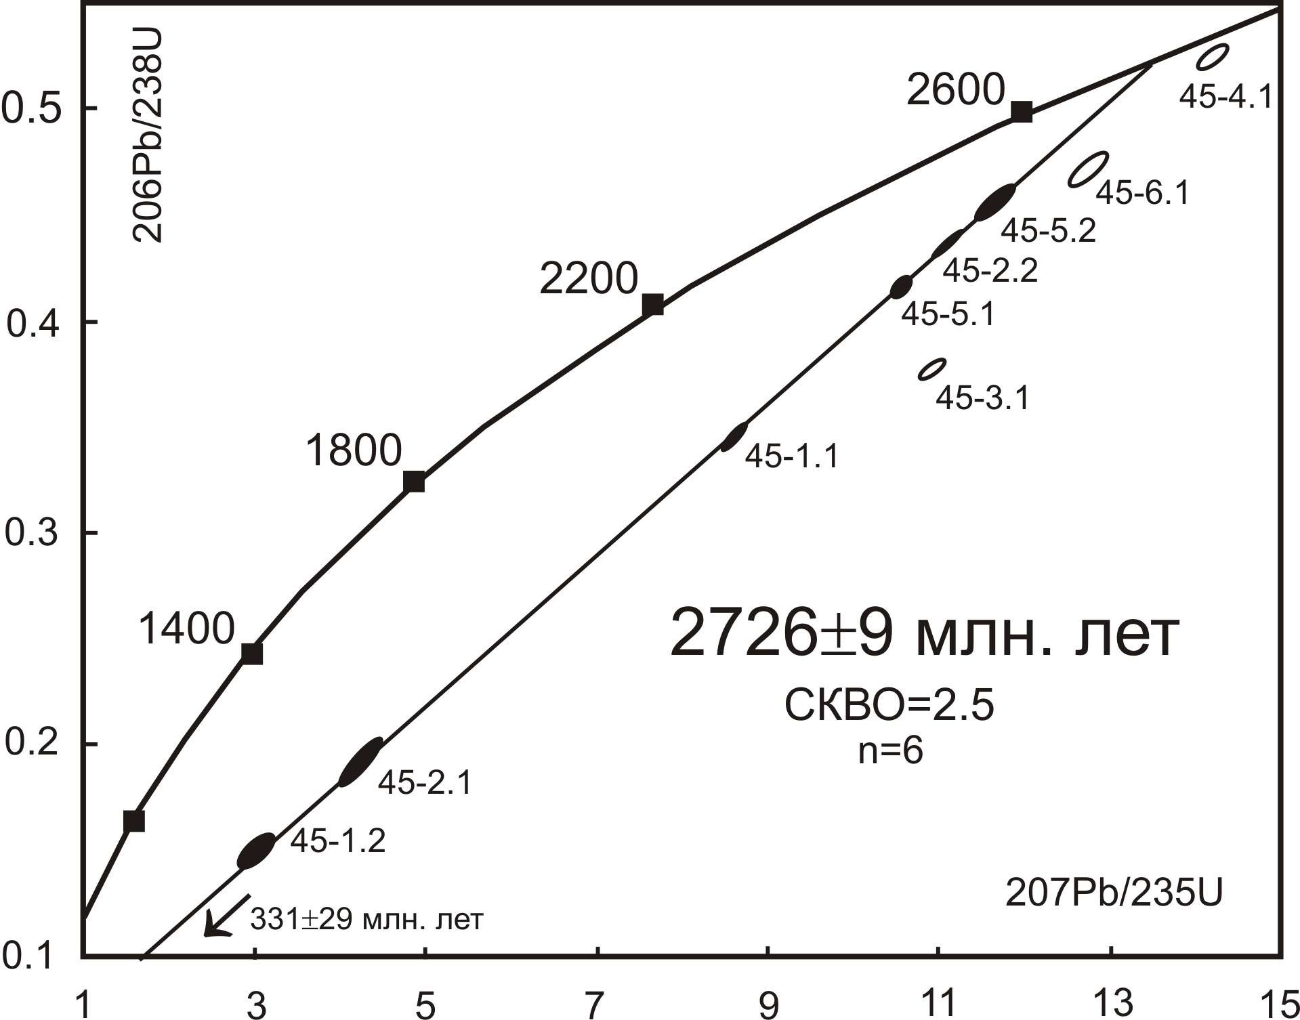
Fig. 2. Diagram with concordia for the tourmaline-muscovite granites. Gray ellipses - analytical data included in the calculation of the discordia; transparent ellipses - not included in the calculation.

The obtained zircon ages from two tourmaline-muscovite intrusions located in the northwestern and southeastern parts of the greenstone belt of Kolmozero-Voronya reflect the different stages in the formation of these granites. Thus, rare-metal pegmatites of the sodium-lithium type of the Kolmozero deposit were replaced in time by the development of lithium-cesium type pegmatites.
The studies were carried out with the financial support of the Russian Foundation for Basic Researches, grant No. 16-05-00367. The state project No. 0231-2015-0005.

REFERENCES
Gordienko V.V. Mineralogy, geochemistry and genesis of spodumene pegmatites. Leningrad: Nedra, 1970. 240 p. (in Russian)
Kudryashov N.M., Lyalina L.M., Apanasevich E.A. Age of Rare-Metal Pegmatites
from the Vasin_Myl’k Deposit (Kola Region): Evidence from U–Pb Geochronology of Microlite // Doklady Earth Sciences. 2015. V. 461. Part 2. P. 321–325.
Kudryashov N.M., Petrovsky M.N., Mokrushin A.V. and Elizarov D.V. Neoarchean Sanukitoid Magmatism in the Kola Region: Geological, Petrochemical, Geochronological,
and Isotopic–Geochemical Data // Petrology. 2013. V. 21. № 4. P. 351–374.
Zozulya D. R., Bayanova T.B., Eby G.N. Ceology and Age of the Late Archean Keivy Alkaline Province, Northeastern Baltic Shield // Journal of Geology. 2005. V. 113. P. 601-608.

