УДК 546.59:549(575.1)
Geodynamic conditions, magmatism and composition of ores of gold deposits in Uzbekistan (Western Tien Shan)

Koneev R.I. ¹, Seltmann R.², Khalmatov R.A.³
¹National University of Uzbekistan, Tashkent. ri.koneev@gmail.com
²CERCAMS, Natural History Museum, London, r.seltmann@nhm.ac.uk.
³ Educational and Experimental Center for High Technologies, Tashkent. r.khalmatov@yahoo.com

According to up-to-date conceptions (A.S.Yakubchuk, R.Seltmann, R.Goldfarb, etc.), industrial gold mineralization in Uzbekistan is located within the South Tien Shan orogenic belt and the Beltau-Kuramin volcanic-plutonic arc, which were formed as a result of the subduction of the crust of the Turkestan paleocene under the Kazakhstan continent , its collision with the Karakum Continent and subsequent post-collisional processes. The deposits are grouped into three ore regions: Kyzylkum, Nurata and Kuramin, which were formed as a result of intersection of the belts with hidden, transformational, deep faults (Figure).
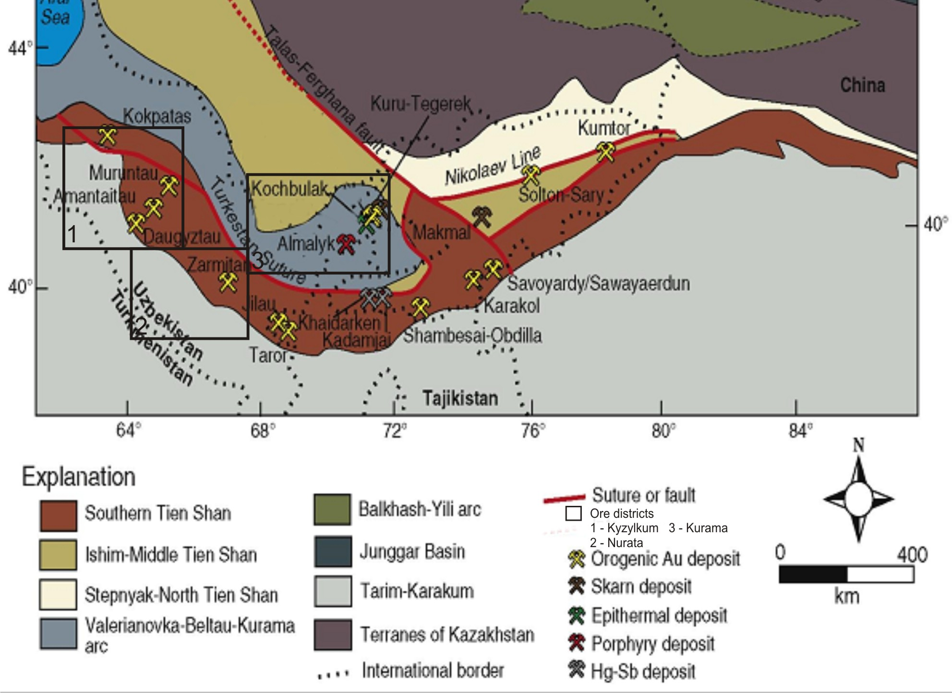
The position of gold deposits in geodynamic structures of the Tien Shan
(Goldfarb et all., 2013)

As a result, orogenic deposits of gold were formed in the South Tien Shan belt, and in the Beltau-Kurama Au-Cu (Mo) porphyry and epithermal deposits.
The different nature of the geodynamic and ore-forming processes occurring in the two belts is confirmed by the results of determining the absolute age of the U-Pb by the zircon method of 40 intrusive massifs in Uzbekistan (Dolgopolova et all, 2016). It was revealed that magmatism of two tectonic stages is manifested in the territory of Uzbekistan: Hercynian and Caledonian. Hercynian ages are divided into two intervals: 270-290 million years and 300-320 million years. The first interval corresponds to the post-collisional magmatism of the South Tien Shan orogenic belt, the second refers to the subduction period and developed in the Beltau-Kuramin volcanic-plutonic arc. The study of the most common, early sulfides (arsenopyrite, pyrite, molybdenite) Re-Os method showed that the age of gold mineralization corresponds to the age of Hercynian granitoid magmatism, but for supersubduction deposits of the volcanic-plutonic arc - Kochbulak, Kyzylalmasay, Kalmakyr, it refers to the upper-Carboniferous period (296-316 million years), for the orogenic deposits Muruntau, Myutenbay, Zarmitan – to the Lower Permian period (286-288 million years).
The deposits of the Kyzylkum and Nurata regions belong to the hypo- mesothermal, Kurama to meso-epithermal. They are located in rocks of different composition - black shales, sedimentary-volcanogenic rocks, granosyenites, andesidzacite volcanics, granites, carbonate rocks. All rocks are changed as a result of metasomatic processes to create a favorable environment for the deposition of gold mineralization, leveling the diverse composition of the enclosing rocks.
Ore formation is in principle a standard physicochemical process that leads to the formation of regular, zonal series of mineral-geochemical types in all gold deposits, regardless of the composition of the host rocks (from the bottom up): /Au-W/Au-Te-Bi/Au-As/Au-Te-Ag/Au-Ag-Se/Au-Sb/Au-Hg/ (Koneev et al., 2010). Each type is characterized by its own formation conditions, mineral associations, gold compounds and regular micro-nanoassembles (table).
In the orogenic deposits of the Kyzylkum and Nurata districts, all types of ores are shown, in the epithermal Kuramin region only Au-As, Au-Ag-Te and Au-Ag-Se. Depending on the conditions for the formation of deposits and their erosion cut in ore can be combined and determine the industrial resource of a different number of types. For example, in Muruntau - Au-W, Au-As, Au-Te-Bi; Charmatine Au-W, Au-As, Au-Te-Bi, Au-Sb; Kyzylalmasay - Au-As, Au-Ag-Se; Kochbulak - Au-As, Au-Ag-Te.

Table
The main types of gold mineralization in the fields of Uzbekistan
Type,  impurity elements | Mineral association | Gold compounds | Micro- nanoensemble | Example of deposits
Au-Hg  As, Sb, Se, Tl | Mercurial:  cinnabar, realgar, | Amalgam Au, Au₂Ag, AuAg | Kongsbergite, schwatzite, tiemannite, crookesite | Karasu  Jasaul  Akchisay
Au-Sb  Pb, Cu, Ag, Se, Hg | Antimony-sulfoantimony: antimony, pyrite, tetrahedrite | Aurostibite (AuSb₂)  Au₄Ag, Au₃Ag | Jamesonite, bournonite, boulangerite, miargyrite, andorite | Amantaytau Daugyztau Guzhumsay  Zarmitan
Au-Ag-Se  Sb, Cu, Te, Hg | Sulfosal-selenide:  pyrite, galena, freibergite, akantite | Petrovskaite  (AuAgS) Fishesserit (AgAuSe₂), AuAg | Pyrargyrite, polybasite, stephanite, naumannite, aguilarite, cervellite | Kosmanachi  Visokovol’tnoe  Adzhibugut  Kyzylalmasay  Chadak
Au-Ag-Te  Sb, Cu, Pb, Bi, Se, Hg | Silver-telluride:  pyrite, galena, chalcopyrite, tetrahedrite | Calaverite (AuTe₂)  Petzite  (Au₃AgTe₂), Au₈Ag, Au₂Ag | Hessite, altaite, tellurantimony, coloradoite,  tetradymite, junoite, chatkalite | Amantaytau Visokovol’tnoe  Kochbulak  Kayragach  Samarchuk
Au-As  Co, Ni | Pyrite-arsenopyrite:  As-pyrite, arsenopyrite | FeAuAsS, FeAuS₂ | Cobaltite, gersdorffite, loellingite, pentlandite, violarite | Muruntau  Zarmitan  Kyzylalmasay Kochbulak
Au-Bi-Te  Se, Sb, Zn | Bismuth-telluride:  Arsenopyrite, pyrite, bismuthinite, sphalerite | Maldonite (Au₂Bi), Au₈Ag,  Au₄Ag, Au₃Ag | Pilsenite, hedleyite, tsumoite, joseite, kobellite, gustavite, Te-canfieldite | Muruntau, Myutenbay, Zarmitan,  Urtalik
Au-W  Mo, REE | Rare-metal:  scheelite, molybdenite | Dispersed | Wolframite, tungtenite | Muruntau  Zarmitan

We note the constant presence of Au-As, pyrite-arsenopyrite type on all deposits, which determines the main volume of quartz-sulfide ore bodies and the main resource of early, scattered, invisible gold.
The convergence in time with granitoid magmatism, the confinement to the nodes of the intersection of deep structures, the constancy of the standard series of mineral-geochemical types irrespective of the host rocks, the contrast composition of each type, the regular, zonal nature of their deposits allows to suggest the genetic relationship of gold mineralization with granitoid magmatism and transform faults. The source of gold and associated ore elements, apparently, were mantle plumes. The average content of elements in stone chondrites, taken as the standard of the upper mantle, is ten times higher than their clark in the earth's crust (g/t): Au 0.17 (0.0043), Te 0.5 (0.001), Se - 10 (0.05), Hg-3 (0.083), Ni-1% (58 g/t).
The research was carried out with the support of the grant of the Ministry of Innovative Development of the Republic of Uzbekistan OT-F8-01.

REFERENCES
Journal articles:
1. Dolgopolova A., Seltmann R., Konopelko D. & Koneev R., Divaev F. Geodynamic evolution of the western Tien Shan, Uzbekistan: Insights from U-Pb SHRIMP geochronology and Sr-Nd-Pb-Hf isotope mapping of granitoids // Gondwana Research, 2016. P. 1-34. http://dx.doi.org/10.1016/j.gr.2016.10.022
2. Goldfarb R., Taylor R, Gregory S. Collins et. al. Phanerozoic continental growth and gold metallogeny of Asia // Gondwana Research, 2013. P. 1-55. http://dx.doi.org/10.1016/j.gr.2013.03.002
3. Koneev R., Khalmatov R. and Mun Yu. Nanomineralogy and nanogeochemistry of ores from gold deposits of Uzbekistan // Geology of ore deposits, Vol. 52, No 8, 2010, pp.755-766.

