PETROLOGY AND EVOLUTION OF LATE ARCHAEAN MONZOGRANITES OF KALYANADURGAM, WAJRAKARUR KIMBERLITE FIELD, EASTERN DHARWAR CRATON, INDIA

Phani P.R.C.¹, Srinivas, M.²
¹Cyient Ltd., Hyderabad, ²Osmania University, Hyderabad, India, phaniprc@gmail.com

ABSTRACT

Petrological and evolutionary aspects of monzogranites exposed at Kalyanadurgam within the Wajrakarur Kimberlite Field of the eastern Dharwar craton (EDC), southern India are discussed. Geologically, the southern Indian craton is divided into two halves viz., eastern and western Dharwar cratons- EDC and WDC respectively. The study area forms a part of gneiss- granite terrane in western part of the Wajrakarur Kimberlite Field (WKF) within the eastern Dharwar craton (EDC). The N-S trending greenstone domain, Ramagiri Schist Belt (RSB) cuts across the WKF (Ramakrishnan and Vaidyanadhan, 2008) attaining a maximum width of 6 km in the southern flank. The Proterozoic sedimentary syclinorium, Cuddapah Basin is situated on the eastern side of the study area. The craton as a whole forms a favourable geotectonic province for emplacement of more than 45 kimberlite/lamproite pipes manifesting ultrapotassic magmatism (e.g. Chalapathi Rao et al., 2016; Shaikh et al., 2016) (Fig.1).

The study area broadly comprises different varieties of granitoid suites, which are designated as, Tonalite- Trondhjemite- Granodiorite suite (TTG), Tonalite-Granodiorite- Monzogranite suite (TGM) and Monzogranite- Syenogranite suite (MS). The present study is focussed on the petrogenesis and evolution of the monzogranites of MS- suite, which are members of late Archaean Closepet granites of the EDC. These granites belong to late Archaean age, i.e., 2513± 5 Ma (U-Pb age, Friend and Nutman, 1991), 2518±4 Ma (Pb-Pb Zircon age, Jayananda et al., 1995). The monzogranite outcrops extend over a length of 10 km with an average width of 3 km, on the immediate west of Kalyanadurgam town (Fig. 2). These are younger granitoids intruded into TTG and TGM as well as RSB litho-units, occurring as isolated or group of outcrops owing to the size of intrusive body. The Peninsular Gneissic Complex (PGC) is intruded with number of dolerite dykes while the monzogranites are often associated with felsic pegmatitic and aplitic intrusive phases.

The monzogranites are leucocratic, pink and/or grey in colour depending on feldspar colour, coarse-grained, occasionally porphyritic, massive and lack foliation. Rarely, they possess mafic enclaves with xenocrysts of K-feldspar, presumably derived from host rock granitoid. Under the microscope, these rocks display hypidiomorphic texture. The essential minerals are alkali feldspar, quartz and plagioclase. Alkali feldspar is mostly microcline and anhedral, exhibiting combined albite-tartan twnning. Plagioclase is subhedral to anhedral. The partly chloritised mafic mineral phase ranges from 10-20% by volume. Biotite is the dominant mafic mineral along with minor amounts of amphibole and its chloritised equivalent. Accesory mineral phases include zicon, titanite and iron oxides. Sericitisation is a common feature in both K-feldspar and plagioclase (Fig. 3).

Whole rock geochemical data has been used to plot various kinds of binary and ternary diagrams. The monzogranite- syenogranite litho-suites are characteristically rich in potassium ranging from 4 to 5.5%, as evidenced by the presence of abundant K-feldspar. In the CIPW norms, the monzogranites are mostly hypersthene normative and show calc-alkaline trend, which is also supported by AFM diagram (Irvine and Baragar, 1971). The monzogranites plot in the ‘subalkaline field’ in alkali-silica diagram (Irvine and Baragar, 1971). In the Shand’s Index diagram, the monzogranite samples straddle close to the margin of metaluminous and peraluminous fields (Maniar and Piccoli, 1989). The samples display a peraluminous and S-type character (Chappel and White, 1974). The trace element bivariant diagram of 10⁴xGa/Al versus Zr (ppm) shows that the monzogranites plot in the ‘I & S- type granite’ fields (Whalen et al., 1987). In the Y versus Nb and Yb versus Ta (ppm) binary diagrams, the majority of the samples plot in the VAG and VAG + syn COLG

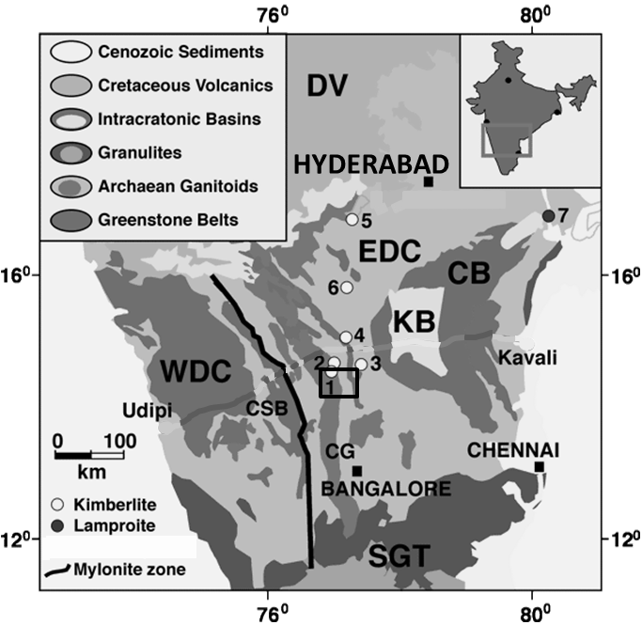  Figure 1. Regional Geological map of Dharwar craton. (modified after Griffin and O’Reilly, 2004). WDC-Western Dharwar Craton, EDC-Eastern Dharwar Craton, SGT, Southern Granulite Terrain, EGGT-Eastern Ghats Granulite Terrain, CB-Cuddapah Basin, KB-Kurnool sub-Basin, DV-Deccan Volcanics, GG-Godavari Graben, CSB-Chitradurga Schist Belt and CG-Closepet Granite. Kimberlite/Lamproite clusters:  1-Kalyandurgam, 2-Brahmanapally, 3-Chigicherla,  4-Wajrakarur, 5-Mahabub Nagar, 6-Raichur and  7-Ramannapeta. The monzogranites of the present investigation are part of linearly trending CG lithological unit at location 1. | 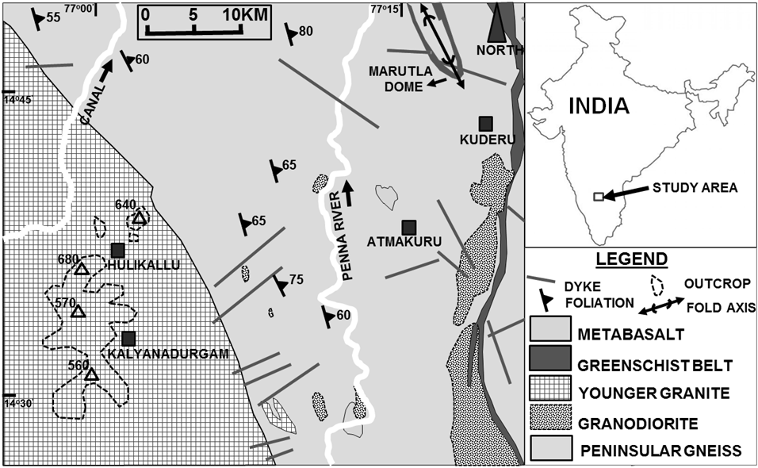  Figure 2. Simplified geological map of the study area (modified after GSI, 2001). Hollow traingles represent altitude of hill peaks in meters, above mean sea level (MSL).  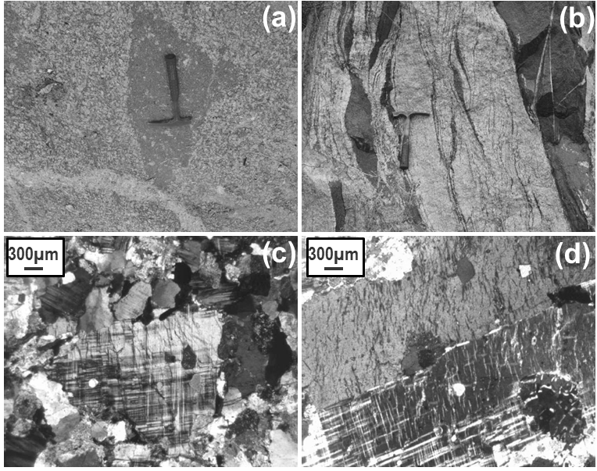  Figure 3. Field and petrographic features of monzogranites of the study area. (a) Mafic enclave mixed with felsic minerals within monzogranite. (b) Melanoccratic mafic enclaves in monzogranite at Hulikallu. (d) Microphotograph showing porphyritic texture with microcline, quartz and biotite (XPL). (d) Microphotograph showing combined albite- tartan twining in microcline.
(volcanic arc granites + syn-colision granites) tectonic regimes (Pearce, 1984). The samples show high concentrations of ƩREE and show conspicuous fractionation pattern when compared to other granite variants of the study area. The monzogranites exhibit both positive as well as negative Eu anomalies. The mafic enclaves observed sporadically in the monzogranites, plot in the calc-alkaline field in the AFM diagram (Irvine and Baragar, 1971) and in alkaline field of alkali-silica diagram (Irvine and Baragar, 1971). The mafic enclave shows high concentration of ƩREE, in particular the LREE. Both LREE and HREE show a gradual fractionation trend. Interestingly, the mafic enclaves show no Eu anomaly. The mafic enclave samples plot in the continental arc to within plate calc-alkaline fields. In view of the high REE content, the monzograites and associated felsic-mafic veins of Kalyanadurgam deserve further investigations to ascertain presence of any rare mineralization.

Absence of metamorphic textures in these monzogranites suggests that they post-date the regional metamorphic events which impacted the PGC (Friend, 1984). The tectono- magmatic and geochemical characters of this ensemble reflect the evolutionary sequence of Archaean crustal segment of the study area. The younger, K rich- monzogranites are largely anatectic, formed by recycling of already existing crust with limited interaction of mafic magmas. A characteristic change in the nature of mafic magmatism from island arc tholeiite as exemplieifed by TGM to K- and REE rich mafic magmatism of continental arc or within plate setting is clearly apparent in this part of the EDC. The monzogranites appear to be I- type, emplaced syn- to late kinematically woth the second phase of deformation of Dharwar Orogeny (Misra and Sarkar, 1998). The gneiss- granite terrane surrounding the WKF-RSB comprises a polyphase-polygenetic gneiss-granite ensemble. The strong positive Eu pulses indicate involvement of plagioclase feldspar fractionation at the time of evolution of these monzogranites. Presence of partially digested country rock enclaves appears to have impeded extensive melting of the PGC rocks to generate monzogranite, rather melting of the PGC rocks appear to be partial. The felsic magmatism changes from primitive Na- Ca dominant, to progressively K- rich phase through time resulting from change in the geochemical signature and intensity of interaction of mafic magmas with felsic magmas, as inferred from the present petrochemical studies, which is in validation with similar rock types in the Dharwar Craton and also on Archaean cratons of other parts of the world.

Keywords: mozogranite, petrography, petrogenesis, petrology, evolution, late Archaean, Dharwar craton, EDC, India.
References
Chalapathi Rao NV, Dongre AN, Wu FY, Lehmann B, (2016) A Late Cretaceous (ca. 90 Ma) kimberlite event in southern India: implication for sub-continental lithospheric mantle evolution and diamond exploration Gondwana Research. http://dx.doi.org/10.1016/j.gr.2015.06.006
Chappel BW and White AJR (1974) Two contrasting granite types, Pacific Geology, 8, 173-174.
Friend CRL (1984) The origin of the Closepet Granites and the implications for the crustal evolution of southern Karnataka, J. Geol. Soc. Ind., 25, 73-84.
Friend CRL, Nutman AP (1991) SHRIMP U- Pb geochronology of the Closepet Granite and Peninsular Gneiss, Karnataka, south India. J. Geol. Soc. Ind., 38, 357- 368.
Griffin WL and O’Reilly SY, 2004 Kimberlites and lamproites probe the deep crust of the Dharwar craton, south India. http://gemoc.mq.edu.au/Annualreport/annrep2004/Reshighlights04.html
GSI (2001) District Resource Map Scale 1:250000, 1.Geology and Mineral Resources, Geological Survey of India, 2001.
Irvine TN and Baragar WRA (1971) A guide to the chemical classification of the common volcanic rocks, Can. J. Earth Sci., 8, 523-548.
Jayananda M, Martin H, Peucat JJ, Mahabaleswar B (1995) Late Archean crust-mantle interactions: geochemistry of LREE- enriched mantle derived magmas. Exampleof the Closepet Batholith: southern India. Contrib. Mineral. Petrol., 119 (2-3), 314- 329.
Maniar PD and Piccoli PM (1989) Tectonic Discriminaiton of Granitoids, Geol. Soc. Am. Bull., 101, 635-643.
Misra S, Sarkar SS (1998) Petrogenesis of Closepet Granite, South India: a Reappraisal, Indian J. Earth Sc., 25 (104), 68-93.
Pearce JA, Harris NB and Tindle AG (1984) Trace Element Discrimination Diagrams for the Tectonic Interpretation of Granitic Rocks, Journal of Petrology, 25, Part 4, pp. 956- 983.
Ramakrishnan, M. and Vaidyanathan, R. (2008) Geology of India, Vol. 1, Geological Society of India, Bangalore, 556p.
Shaikh AM, Patel SC. Ravi S, Behera D, Pruseth KL, (2016) Mineralogy of the TK1 and TK4 ‘kimberlites’ in the Timmasamudram cluster, Wajrakarur Kimberlite Fiels, India: Implications for lamproite magmatism in a field of kimberlites and ultramafic lamprophyres. Chemical Geology, In Press, 23 p. http://dx.doi.org/10.1016/j.chemgeo.2016.10.030.
Whalen JB, Currie KL and Chappel BW (1987) A-Type granites: Geochemical characteristics, discrimination and petrogenesis, Contrib. Min. pet., 95, 407- 419.

