GEOCHRONOLOGY OF CATANDA CARBONATITIC INTRUSION AND SURROUNDING GRANITES (ANGOLA) – PRELIMINARY STUDIES

*Wołkowicz S.1, Krzemińska E.1, Wołkowicz K.1, Jackowicz E.1, Czupryt Z.J.1*

*1Polish Geological Institute-National Research Institute, Warsaw, Poland,* [*stanislaw.wolkowicz@pgi.gov.pl*](mailto:stanislaw.wolkowicz@pgi.gov.pl)

**Introduction and geological setting**

Catanda carbonatite massif (Cuanza Sul Province), as well as carbonatites from other occurrences in Angola belongs to the Parana-Angola-Namibia magmatic province. The carbonates of this province are most often found in the form of intrusive bodies in central parts of alkaline complexes, rarely appear as extrusive or effusive volcanic products. **The igneous and volcanic phenomena were related to the tectonic activity in deep crustal propagating faults cutting the South American and African platforms far landward.** Catanda carbonatite massif is still poorly and fragmentarily recognized compared to other carbonatite structures of the Lucapa structure, although it represents very attractive research material coming from rare occurring extrusive carbonatites. Catanda massif (Fig. 1) covers an area of about 80 km2 and have penetrated Precambrian basement built of granites, migmatite-granite gneisses, quartz schists and diabases and is directly overlain by eluvial-aluvial sediments originating from their weathering (Pinheiro, 2008).

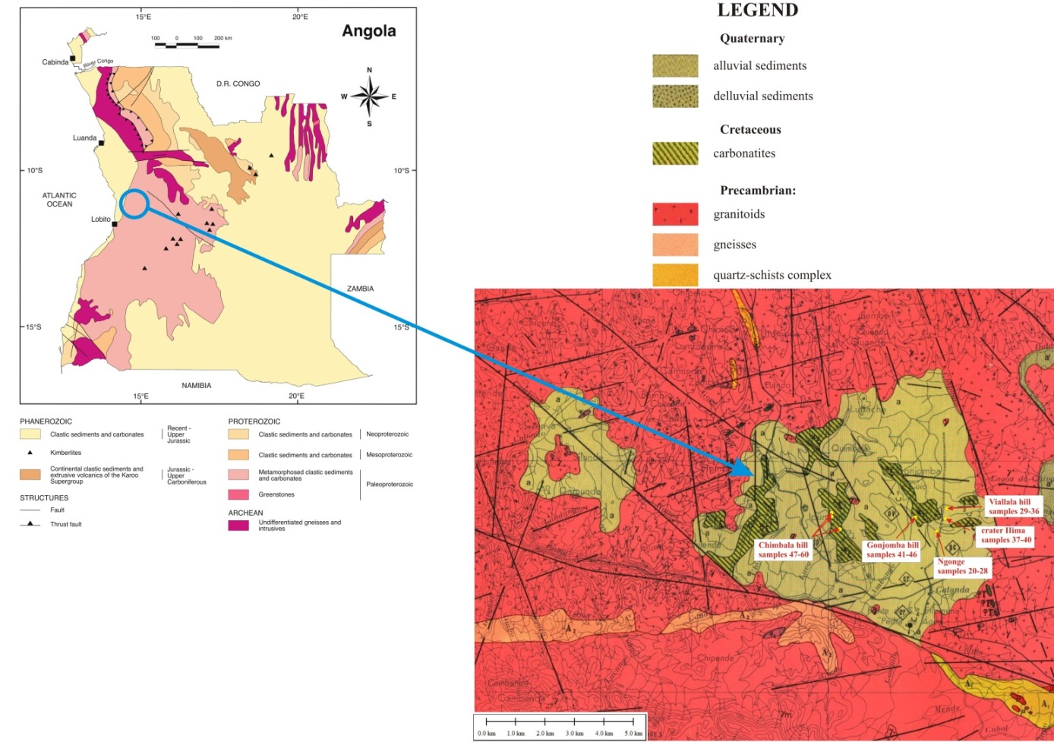

Fig. 1. Geological map of Catanda carbonatitic massif (after Silva, 1973b) with marked sampling points.

Previous studies have shown that carbonatite complexes from Catanda are dominated by pyroclastic rocks, Previous studies have shown that Catanda carbonatite complexes are volume-dominated by pyroclastic rocks, reaching thickness up to 100 m.

These rocks are generally classified as carbonatite tuffs (Silva, 1973a), representing several cycles gradation stratigraphic cycles. In the lower part of the cycles there are agglomerates composed with igneous and metamorphic rocks (granitogneisses, amphibolites, carbonatites and other alkaline rocks), and in the upper ones are carbonatitic lapilli-ash tuffs. Carbonatitic lava forms streams up to several meters thickness, interbedding pyroclastic rocks (Campeny et al., 2012). According to Silva (1973a) these lava are composed of phenocryst of pyroxenes, amphibolites, olivine, biotite, apatite and opaque minerals and microcrystalline, sometimes carbonatic groundmass with apatite, magnetite, pyrochlore and baddeleite. Numerous bubbles are filled with calcite, sometimes barite and kaolinite. As a result of subsequent studies of Catanda carbonatite complexes, lavas were divided into carbonatites and natrocarbonatites (Bambi et al., 2008a), or calciocarbonatites and silicocarbonatites (Campeny et al., 2012). Natrocarbonatites are called lavas, whose phenocrysts are pseudomorphs after nyerereite, and the microcrystalline, calcitic groundmass contains accessory pyrochlore, baddeleite and spinels (Bambi et al., 2008b).

The division into calciocarbonatites and silicocarbonatites was based on the results of the study of the main elements, which was confirmed by the mineral composition of these lavas. Calciocarbonatites are composed of calcite and apatite phenocrysts and calcite groundmass, while silicocarbonatites are aphyric, and their groundmass contains calcium silicates, apatite, ulvospinel, perovskite, pyrochlore and periclase (Campeny et al., 2012). The content of 13C and 18O isotopes in calcite of carbonatites are not typical for mantle magma and indicate the significant influence of the continental crust on the formation of their composition (op.cit.). Perhaps this is due to the long-term hydrothermal activity, as described by Silva (Silva, 1973a) in four craters of hot springs containing calcium or sodium carbonates.

**Analytical methods**

Age isotopic investigations were realized on monomineral concentrates separated from hand samples 51D and 43 (tuffs an altered lava flow) using conventional procedure ( e.g. heavy liquids, magnetic separation and hand peacking). U-Pb measurements have been done on zircons and pyrochlore single grains. In bot of cases Temora2 zircon standard was used as a basic reference material with ratio 206Pb/238U= 0.06683 206Pb*/238U age of 416.78±0.33 by TIMS (Black et al., 2004).

The similar analytical procedure was applied for U-Pb datings of pyrochlore from Nsungwe Formation (Roberts et a al. 2010).

The zircon and pyrochlore mounts were imaged on Nikon EclipseLV100NPol optical microscope in transmitted and reflected light mode using NIS Elements BR software and on scanning electron microscopy using CL and BSE detector of HITACHI SU3500 to check homogeneity and internal features of grains and to select a proper place for analyses.

The software of SQUID2.50.11.01.03 and attached Isoplot/Ex v.3.0 Macroof Ludwig (2003) were used for data processing and visual form of results are presented on Tera- Waserburg (207*Pb/206*Pb versus 238U/206*Pb) oraz Wetherilla (206*Pb/ 238U versus 235U/207Pb) concordia diagrams.

In case detrital zircons and high number data it was necessary to use aprobability plots and histograms, which are a basic form of data presentation and comparison of age groups and number of populations, that reflect probable source rocks and areas.

**Results and conclusions**

The age of carbonatite ash and lava flow from Catanda is a matter of longstanding debate. Zircons separated from volcanic ash layers are commonly inferred to date the time of a volcanic eruption. Thus it was one of the basic aim of presented study.

However, this assumption is often problematic due to inheritance or incorporation of slightly older zircons that were derived from older rocks and entrained in the eruption column. Moreover carbonatite may contain a lesser amount of accessory zircon phase. Only two samples (43 and 51D) provided some amounts grains, that allow to perform U-Pb age study. The zircons reveal variability from euhedral to subhedral with shapes ranging from elongate prismatic to squat equidimentional forms, suggesting on the beginning a significant contribution of non-volcanic material. All extracted grains e.g. 74 zircons from sample 51D and 44 zircon from sample 43 were checked and a total of 118 grains were analysed. Zircon age populations are similar in both samples and yielded 207Pb/206Pb age in range from 3274 ± 83 Ma to 1896± 26 Ma.

The resultant age data plot a cluster on or around concordia, defining a dominating Paleoproterozoic age of epiclastic material. The similarity of U-Pb zircon record both samples is shown on isotopic radio data set visualized on Tera –Wasserburg concordia diagram and on relative probability plot (Fig. 2), where the compilation of Pb-Pb concordant ages from samples (51D and 43) reveal single



Fig 2. Catanda epiclastic zircon U-Pb age results compiled on Concordia diagram and on relatively probability plot .

modal distribution peaked at 2016 Ma. Moreover, for each sample the most coherent group of grains within error is the same, defining crystallization age of dominated source rocks at 2037±9.9 Ma and at 2031.2±10 Ma respectively. These result perfectly corresponds with age of the local Palaeoproterozoic granitic magmatism documented recently (McCourt et al., 2013) in the Lubango Zone (Lubango with upper intercept age of 2038± 28 Ma) that forms part of southern Angola crustal terrane (Angolan Shield), linked to an active continental margin of that age.

Oxygen isotope ratios of detrital zircon have been used to evaluate the degree of addition of crustal material, because grains that crystallise from mantle derived magmas tend to record a rather narrow range of δ 18O values falling lose to 5.3±0.3‰. Assimilation of crustal components is usually expressed by elevated oxygen isotope composition. The δ 18O values of examined zircons range from 3.95±0.23‰ to 7.36±0.18‰ with mean δ 18O VSMOW values of 6.32±0.15‰ (Wołkowicz et al. 2016).

Carbonatite-specific mineral remain a pyrochlore. Presence of compositionally zoned and euhedral and visually fresh grains of pyrochlore as an accessory phase in carbonatite ash and lava allowed to test the geochronological potential of pyrochlore. Because of expected high abundances of U and Th, the EMP chemical analysis have been performed before the isotopic study. BSE-textures include mostly homogeneous cores and distinct composition of thin rims (Fig. 3 A). Nb, Ti, Ca, and Na generally show only small variations within individual crystals (e.g., ,12.5–16.6 wt% CaO) with amount of niobium up to 68 wt% Nb2O5. In contrast, U and Th concentrations are highly variable and range over 0.2–2.0 wt% and 0.6–6.4 wt%, respectively. The amount of Pb was typically below detection limit of WDS. In general terms pyrochlores extracted from samples 43 and 51D follow regional chemical trends of alteration (Bambi et al., 2012, Torro et al. 2012). The grains contain up to 3 wt.% SrO and variable amount of F (Fig. 3B). Some grains of pyrochlore have clearly secondary genesis having F-, Ca-and Na- rich compositions, but some crystals are not strongly altered and reveal composition close to those from the typical primary pyrochlores.

U-Pb-Th analyses of pyrochlore grains from Catanda tuff are complicated because the lead concentration is typically low, with variable but relatively high amounts of common-Pb contamination. In consequence preliminary results have relatively large uncertainties and discordances. First data set confirmed that composition of grains is extremely variable (Fig. 3C) with few young results 206Pb/238U below 5 Ma.

Calculated isochron for cogenetic samples yielded age of about 26.6 ±6.7 Ma (MSWD= 0.25) with low initial 207Pb/204Pb, needs more refinements by additional measurements. Such imprecise result, however may tentatively suggest a slightly younger time of effusive activity in Catanda, that correlates with age of carbonatite tuff from the Nsungwe Formation of 24.93±0.49 Ma, known from south western Tanzania defined also on pyrochlore grains (Roberts at al. 2010).



Fig.3. Chemical and Isotope composition of pyrochlore grains from Catanda tuffs. BSE image and WDS composition on SrO vs F diagram with data for comparison taken from Bambi et al. 2012 and Torro et al. 2012 and preliminary U-Pb age constrain.

**References**

Bambi A., Costanzo A., Melgarejo J., Gonçalves A., Alfonso P., Neto A., Manuel J. (2008a) Evolution of Pyrochlore in Carbonatites: the Angola Case. Macla 9: 43-44.

**Bambi A. J. M., Costanzo A., Manuel J., Alfonso P., Olimpio A., Melgarejo J. C. (2008b) Natrocarbonatite flows and pyroclastic deposits in the early Cretaceous Catanda carbonatite volcanoes. Publications of the 33rd International Geological Congress, Oslo, Norway.**

Bambi, A., Costanzo A., Goncalves A.O., Melgarejo J.C. (2012) Tracing the chemical evolution of primary pyrochlore from plutonic to volcanic carbonatites: the role of fluorine. Mineralogical Magazine, 76(2): 377-392.

Black, L. P., Kamo, S. L., Allen Ch.M., Aleinikoff J.N., Davis D.W., Korsch R.J., Foudoulis, C. (2003) TEMORA 1: a new zircon standard for U-Pb geochronology. Chem. Geol., v. 200: 155-170.

Campeny M., Alfonso P., Melgarejo J.C., Mangas J., Bambi A., Manuel J. (2012) Carbon and oxygen isotopes of the carbonatitic lavas from Catanda, Kwanza Sul, Angola: genetic implications. European Mineralogical Conference Vol. 1, EMC 2012-438.

McCourt S., Armstrong R.A., Jelsma H., Mapeo R.B.M. (2013) New U-Pb SHRIMP ages from the Lubango region, SW Angola: insightsinto the Palaeoproterozoic evolution of the Angolan Ahield, southern Congo Craton, Africa.Journal of the Geological Society v.170; 353-363.

Pinheiro O. Q., 2008 **-** Análise espacial integrada da informação de arquivo do carbonatito de Catanda. Caso das crateras kimberlíticas. Dissertação para obtenção do título académico de Mestre; Universidade Agostinho Neto, Faculdade de Cienias, Departamento de Geologia. Luanda, Angola.

Roberts E.M., O'Connor P.M., Stevens N.J., [Gottfried](https://scholars.opb.msu.edu/en/persons/michael-d-gottfried-2) M.D., Jinnah Z.A., Ngasala S., Choh A.m., Armstrong R.A. (2010) Sedimentology and depositional environments of the Red Sandstone Group,

Rukwa Rift Basin, southwestern Tanzania: New insight into Cretaceous and Paleogene terrestrial ecosystems and tectonics in sub-equatorial Africa. J of African Earth Sciences 57:179 -212.

Silva M.V.S., 1973a. Estrutura Vucanico-Carbonatitica da Catanda (Angola). Boletim dos Servicos de Geologia e Minas, 24.

Silva M.V.S., 1973b. Carta Geologica de Angola. Folha N 207 Gungo. Scale 1:100 000.

# [Torró L.](http://diposit.ub.edu/dspace/browse?type=author&value=Torr%C3%B3+i+Abat%2C+Lisard), [Villanova C.](http://diposit.ub.edu/dspace/browse?type=author&value=Villanova%2C+Cristina), [Castillo M.,](http://diposit.ub.edu/dspace/browse?type=author&value=Castillo%2C+Montgarri) [Campeny M.](http://diposit.ub.edu/dspace/browse?type=author&value=Campeny%2C+Marc), [Gonçalves A.,](http://diposit.ub.edu/dspace/browse?type=author&value=Gon%C3%A7alves%2C+A.+O.) [Melgarejo J.](http://diposit.ub.edu/dspace/browse?type=author&value=Melgarejo+i+Draper%2C+Joan-Carles) 2012 Niobium and rare earth minerals from the Virulundo carbonatite, Namibe, Angola. Min. Mag. 76, 2: 393-409.

Wołkowicz S. et al. 2016,.. The oxygen isotope study of zircon grains from Catanda extrusive carbonatite (Angola). <http://www.americangeosciences.org/sites/default/files/igc/4663.pdf>