UNUSUAL MONAZITES AND СE SEGREGATION PROCESS DURING ALKALINE METASOMATOSIS OF ACID SUBSTRATES (KOSYU ORE FIELD, MIDDLE TIMAN)
Varlamov D.A.¹, Udoratina O.V.², Burakov N.N.³
¹ Institute of experimental mineralogy RAS, Chernogolovka, Russia, dima@iem.ac.ru
² Institute of Geology Komi SC UB RAS, Syktyvkar, Russia, udoratina@geo.komisc.ru,
³ Syktyvkar State University named after Pitirim Sorokin, Syktyvkar, Russia
The ultrabasic, fenite and carbonatite rocks of Chetlassky dike complex are developed in the southern part of Chetlassky Kamen in Middle Timan. The host rocks are terrigenous and terrigenous-carbonate formations of chetlasskaya (R₂) and bystrinskaya (R₃) series. Various alkaline metasomatites (fenites, phlogopite-rich rocks, feldspar metasomatites), carbonatites and hydrothermal vein structures with abundant accessory rare metal – REE mineralization are closely related to the rocks of the complex (Ivensen, 1964, Kostyukhin, Stepanenko, 1987, Nedosekova et al., 2011, 2013). The bodies of the alkaline metasomatites and carbonatites are localized in the same tectonic zones with NE strike as the dike of ultrabasites, but unlike the ultrabasites they occur in separate areas. Enclosing sedimentary metamorphic rocks (sandstones, siltstones, shales and phyllites) form fenites, which are composed of aegirine, alkaline amphibole, microcline and albite; they are often carbonatized. The phlogopite-rich rocks and feldspar metasomatites are developed on the ultrabasites. At that the shape of their bodies is often completely controlled by the morphology of the ultrabasite bodies. The phlogopite-rich rocks and the largest bodies of carbonatites are widespread in the Kosyu fault zone in the area of the massif (“puff-up” of picrite dike) of the Kosyu River, where formation of carbonatites and associated contact processes of metasomatism are especially intense. Here the stockwork zones of goethite-feldspar rocks are noted, which are closely related to the process of carbonatite formation and, probably, present a hydrothermal stage of carbonatites. The latest quartz-goethite-hematite veins with NE strike intersect all the rocks of the massif.
Geological, petrographic and petrochemical studies of recent years on carbonatites and alkaline picrites are given in the works (Nedosekova et al., 2013), mineralogy data in the works (Kovalchuk et al., 2013, Nedosekova et al., 2017), modern (petro-geochemical, mineralogical and isotope-geochemical) data on alkaline metasomatites are practically absent.
Alkaline metasomatites (fenites), developed along sandstones of visingskaya suite of chetlasskaya series, were taken in the riverheads of Kosyu river. The rock forming and rare metal – REE accessory minerals from them were studied. The material for research was obtained during a field trip in 2016. In weakly and strongly fenitized initially badly sorted sandstones and aleurolites (series of thin sections 340-1, -2, 3, etc.) we found both relict and newly formed minerals. Relics of quartz, plagioclase and Kfs are partially preserved, newly formed albite and Kfs (often – barium-containing) form basal cement alongside with chlorite and sericite. We observe the development of hematite and iron hydroxides. In the process of research, a fairly large number of ore and accessory mineral inclusions have been identified, for the diagnosis of which microprobe study is currently conducted in IEM RAS (Chernogolovka).
Among the newly formed rock-forming minerals were established aegirine, alkaline amphibole, Fe-rich chlorite, fluorine-rich phlogopite and their Al-absent «analogue» KMg₂Si₅O₁₀F₂. Among the accessories zircon; different Al-, Ba-, REE phosphates; carbonates: burbankite (Na,Ca)₃(Sr,Ba,Ce)₃(CO₃)₅, norsethite BaMg(CO₃)₂, unknown Ba-Mn carbonates, different F-rich REE-carbonates; extensive range of thorium minerals, Nb-rich rutile, own Ce-minerals with Mn, Fe, Ba, Pb.
In this paper, some types of monazites from these rocks, quite original in composition and possible genesis, as well as probable processes leading to their formation are considered. Of greatest interest is the formation of cerium-deficient monazites (Fig.1, a-c; Table 1, an.1,3) in which the cerium content falls sharply to 5-6 wt% Ce₂O₃ when cerium is replaced by mainly neodymium and, to a lesser extent, lanthanum in comparison with earlier idiomorphic high-cerium thorium-containing monazites of generation I. In contrast, neogenic Ce-deficient monazites II , as a rule, have xenomorphic nature, often fill emptiness or are characterized by a needle-like appearance, often located along the grain of rock-forming minerals. An interesting feature is the high concentration of lead (up to 4% PbO) with almost complete absence of radiogenic elements Th and U. It can be explained either by the non-radiogenic origin of similar lead (that demands padding researches as contradicts the majority of postulates in this area), or peculiar metasomatic processes in the formation of these monozites with removal of thorium and concentration of lead (possibly in form Pb⁴⁺). Also several micrograins of REE fluorocarbonate with the significant decrease in contents of cerium of rather other REE are revealed.

Table 1. Chemical composition (wt. %) of different monazites
 | sample | P₂O₅ | CaO | La₂O₃ | Ce₂O₃ | Pr₂O₃ | Nd₂O₃ | Sm₂O₃ | Gd₂O₃ | PbO | ThO₂ | Total
1 | 340/3-14 | 29.92 | 2.31 | 18.31 | 5.89 | 6.03 | 29.29 | 4.01 | 1.01 | 1.24 | 0.82 | 99.65
2 | 340/3-15 | 33.39 | 0.15 | 11.20 | 29.72 | 3.59 | 14.50 | 2.01 | 1.00 | 0.49 | 3.42 | 99.80
3 | 340/3-19 | 29.54 | 2.20 | 20.45 | 6.15 | 6.46 | 25.53 | 3.11 | 0.50 | 2.79 | n.d. | 98.16
4 | 340/2-1 | 28.36 | 0.42 | 12.09 | 25.95 | 2.59 | 12.30 | 3.94 | 3.30 | 0.61 | 9.27 | 100.62
5 | 340/2-2 | 31.45 | n.d. | 14.53 | 33.79 | 3.68 | 11.61 | 1.54 | 1.25 | n.d. | 0.31 | 100.24
Remark: Composition of monazites is simplified. I generation (2,4), II generation: Ce-deficient low-Th with high content of Pb (1,3); newly formed Ce-rich Th-absent (5). Italic – means lower than 2σ measured.
Together (often practically nearby) still finally not diagnosed own phases of cerium with manganese and iron are formed (table 2; fig. 1 c-d). They are characterized by the absence of other REE, the quite considerable contents of P, Ba and Pb (less often Zn). The impurities Al and Si are probably caused by microinclusions. These phases are localized in aggregates like a containers of iron oxides and hydroxides, Fe- analogues of braunite and high-ferrous (alumo)silicates.
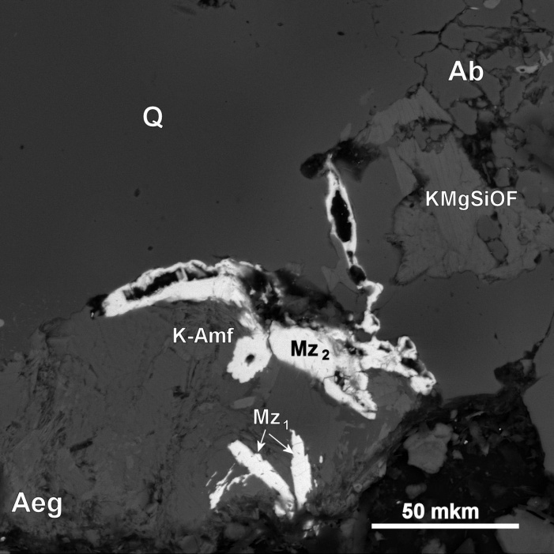  а | 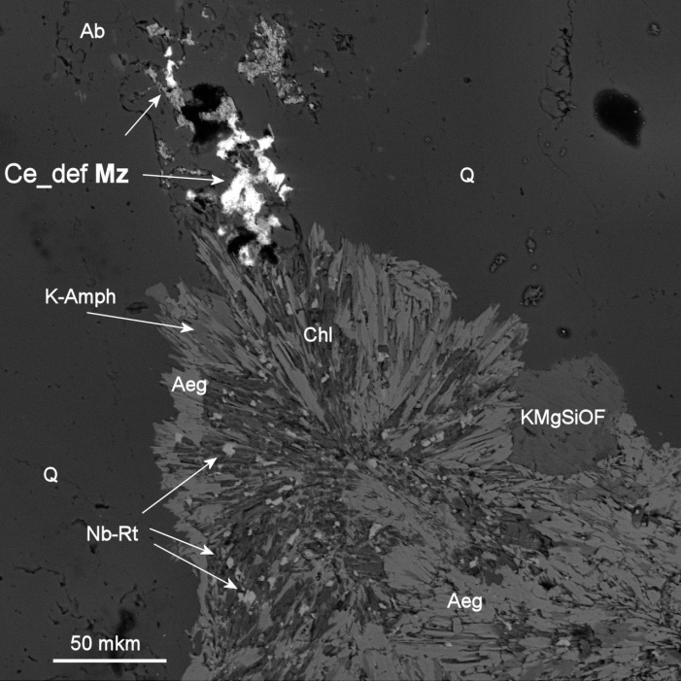  b
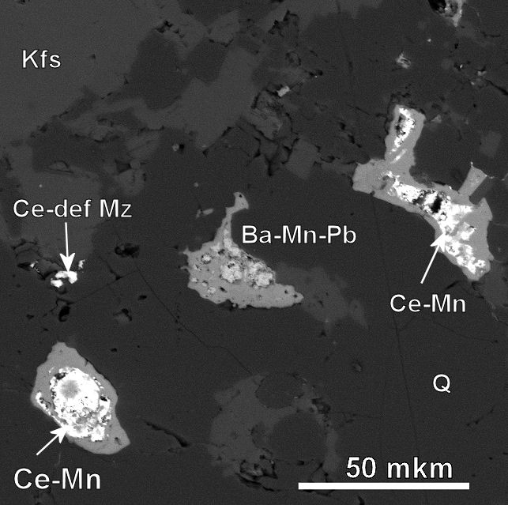  c | 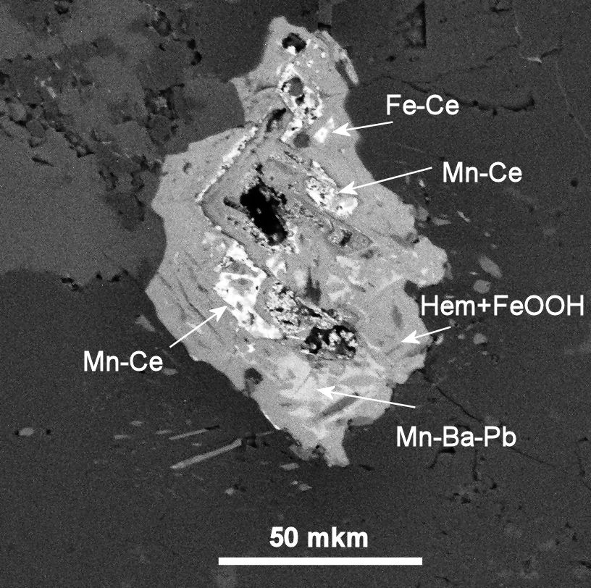  d
Fig 1. Microphotographs of monazites and high-Ce phases: (a) monazites of two generations: I –idiomorphic high-cerium Th-bearing Mz1; II –xenomorphic Ce-deficient Th-absent high-Pb Mz2; b) -xenomorphic Ce-deficient at boundary of Aeg+K-Amf+Rt+Chl “sun-like” aggregate; c) Mn-Ce cores in container of iron oxides and hydroxides: (d) Mn-Ce and Fe-Ce phases in aggregate of iron oxides and hydroxides
The similar combination of Ce-deficient REE minerals and actually cerium phases, in our opinion, is associated with the oxidation of cerium from Ce³ ⁺ to Ce⁴ ⁺ at some stage of the process of fenitization, that at once sharply changes its chemical properties in comparison with group of rare earth elements. Some part of cerium remains trivalent (small amount of cerium in neogenic monazites and the F-rich REE carbonates), however, a majority as Ce⁴⁺ is fixed in own Ce phases of Mn-Ce and Fe-Ce composition. Possibly, this process is bound or is simultaneous with formation of the oxidized ferrous phases – an aegirine, oxides and hydroxides of iron, however, so far early to speak about its correct geological binding.
Table 2. Mn and Fe cerium phases in fenitized quartzite-sandstones (wt.%)
sample |  | Al₂O₃ | SiO₂ | P₂O₅ | CaO | Mn₂O₃ | Fe₂O₃ | ZnO | BaO | CeO₂ | PbO | Total
340/3-21 |  | 4.26 | 2.08 | 4.59 | 0.30 | 13.38 | 6.28 | n.d. | 1.22 | 55.39 | 1.18 | 88.68
340/3-22 |  | 3.94 | 3.00 | 3.83 | 0.59 | 16.12 | 12.53 | 0.48 | 2.27 | 35.21 | 1.49 | 79.46
340/3-26 |  | 2.58 | 4.95 | 3.98 | 0.51 | 2.58 | 28.24 | 0.19 | n.d. | 35.43 | 0.70 | 79.16
340/3-32 |  | 2.98 | 1.73 | 4.20 | 0.34 | 22.97 | 4.68 | 0.24 | 2.76 | 44.93 | 2.18 | 87.01

Also, in the part of the samples, the formation of interesting two-stage monazites was revealed (Fig. 2, analyzes 4-5 in Table 1) having high-thorium (up to 11% ThO₂) idiomorphic or rounded cores (Mz₁), overgrowing amoeboid-like Th-absent Ce-rich aggregates of the second generation (Mz₂). The latter have a porous structure, often contain microinclusions of phosphates (apatites, phosphates Al, Ba, Fe), sometimes enclosed in quartz "containers". Most likely, their formation is associated with the formation of regenerative aggregates of newly formed monazite growing on primary monazites after their partial dissolution. Thorium in this process is mobilized by a fluid with the subsequent fixing in other phases, as evidenced by the appearance of high-thorium F-rich REE carbonates and thorium own phases (xenomorphic thorites, phosphothorites, hydroxothorites, etc.).
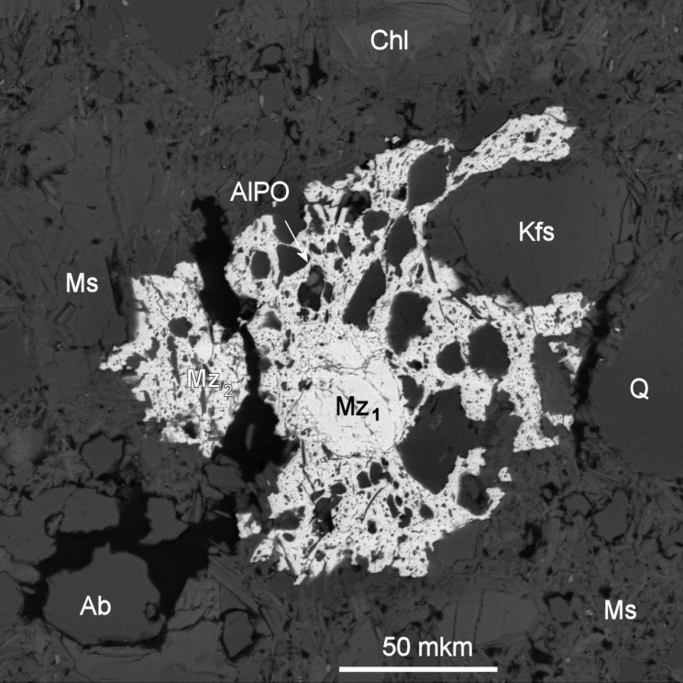 | 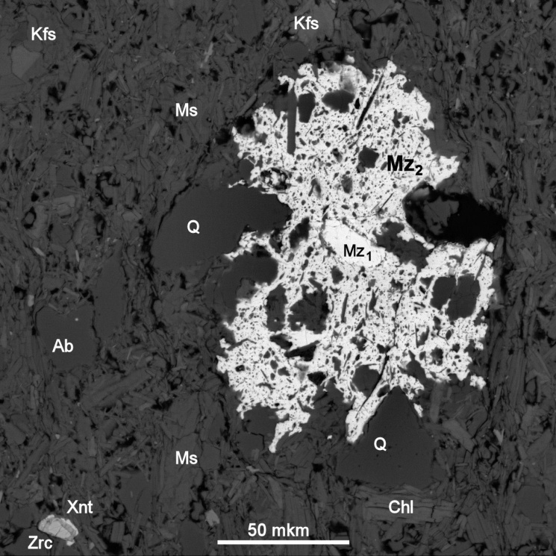
Fig 2. Microphotographs of two generations of monazite: I – Mz₁ round or idiomorphic with high Th content (up to 11% ThO₂) cores; II – Mz₂ amoeboid-like Th-absent Ce-rich shells.
Thus, in fenitized sandstones, the genetically bound to the action of igneous rocks of the Chetlasskii complex on terrigenous rocks of chetlasskaya suite, the processes leading to the oxidation of cerium to the tetravalent state are established and are manifested in the removal of cerium from conventional REE minerals and the formation of characteristic Mn-Ce and Fe-Ce phases. It leads to formation of the unusual low-cerium monazites differing in also high contents of lead (up to 3-4% of PbO) in the absence of radiogenic elements that contradicts postulates on radiogenic character of lead in monazites.
Also, aggregates of monazites formed by chemically different generations have been identified, which indicates quite differently directed metasomatic reactions in the process of fenitization of acid (quartzite sandstone) substrates.

Source of financial support Program UB RAS № 15-18-5-46.

References
Ivensen Yu. P. Magmatism of Timan and Kanin Peninsula // Leningrad: Nauka, 1964. 126 p. (in Russian)
Kostyukhin M.N., Stepanenko V.I. Baikalian magmatism of Kanin-Timan region. // Leningrad: Nauka, 1987. 232 p. (in Russian)
Kovalchuk N.S., Shumilova T.G., Stepanenko V.I., Rare metal mineralization in carbonatites of Kosyu massif (Middle Timan). // ZRMO, No. 3, 2013. pp. 109-132. (in Russian)
Nedosekova I.L., Udoratina O.V., Vladykin N.V., Pribavkin S.V., Gulyaeva T.Ya. Petrochemistry and geochemistry of dike ultrabasites and carbonatites of the Chetlas complex (Middle Timan) // Yearbook 2010, IGG UB RAS, No. 158, 2011, p. 122-130. (in Russian)
Nedosekova I.L., Vladykin N.V., Udoratina O.V., Ronkin Yu. L. Carbonatites of the Chetlas complex (Middle Timan): geochemical and isotopic data. // Yearbook 2012, IGG UB RAS, No. 160, 2013, p. 150-158. (in Russian)
Nedosekova I.L., Zamyatin D.V., Udoratina O.V. Ore specialization of the carbonatite complexes of the Urals and Timan // Lithosphere, 2017, No. 2. (in Russian)

